BCSE497J - Project-I

PREDICTIVE INVENTORY MANAGEMENT SYSTEM FOR KIRANA STORES

23BAI0088 | ADITYA SINGH
23BAI0146 | TANMAY KARTIKAY

Under the Supervision of

Dr. ARTI TIWARI
Assistant Professor Sr. Grade 1
School of Computer Science and Engineering (SCOPE)

B.Tech.
in
Computer Science and Engineering
(Artificial Intelligence and Machine Learning)

School of Computer Science and Engineering



September 2026

ABSTRACT

Effective inventory management is critical for balancing product availability against holding costs and obsolescence. Addressing the complexities of multi-echelon networks, this project proposes a data-driven "Forecast-then-Optimize" architecture. Utilizing the Corporación Favorita Grocery Sales dataset, the system processes highly skewed, real-world transactional data to capture genuine retail dynamics.

To accurately model intermittent demand and varying product shelf lives, the data preparation pipeline evaluates 400 carefully selected, representative store-item combinations. This preprocessing includes strict daily reindexing, chronological train-validation-test splitting to prevent data leakage, and the integration of cyclical calendar, holiday, and promotional features. For demand forecasting, two deep learning architectures are compared under identical conditions: a Temporal Fusion Transformer (TFT) that leverages static metadata and future-known calendar signals, and a PatchTST model focused on historical series patches. Both models use a 28-day historical lookback to predict a 7-day future horizon. Evaluated across R², MAE, RMSE, WAPE, and sMAPE metrics, both architectures substantially outperform a weekly-naive baseline. This rigorous comparison allows for an evidence-based selection of the most suitable model for downstream tasks.

The selected demand predictions directly feed the inventory optimization stage. Because real-world supply chain datasets rarely include complete upstream flow records, the project simulates a simplified three-echelon network (Supplier to Regional Warehouse to Store to Customer). Particle Swarm Optimization (PSO) is then applied to the forecasted demand to systematically optimize inventory policy variables, such as safety stock and reorder quantities, under realistic constraints.

Overall, by bridging the gap between advanced comparative time-series forecasting and combinatorial optimization, this integrated framework demonstrates how AI models and metaheuristics can coordinate to reduce supply chain waste, prevent stockouts, and improve dynamic replenishment decisions at scale.

Keywords - Inventory Management, Demand Forecasting, Supply Chain Optimization, Temporal Fusion Transformer, Particle Swarm Optimization

TABLE OF CONTENTS
Sl.No | Contents | Page No.
 | Abstract | 2
1. | INTRODUCTION | 4
 | 1.1 Background | 4
 | 1.2 Motivations | 4
 | 1.3 Scope of the Project | 5
2. | PROJECT DESCRIPTION AND GOALS | 6
 | 2.1 Literature Review | 6
 | 2.2 Research Gap | 7
 | 2.3 Objectives | 8
 | 2.4 Problem Statement | 8
 | 2.5 Project Plan | 9
3. | TECHNICAL SPECIFICATION | 11
 | 3.1 Requirements | 11
 | 3.1.1 Functional | 11
 | 3.1.2 Non-Functional | 12
 | 3.2 Feasibility Study | 13
 | 3.2.1 Technical Feasibility | 13
 | 3.2.2 Economic Feasibility | 14
 | 3.2.3 Social Feasibility | 15
 | 3.3 System Specification | 15
 | 3.3.1 Hardware Specification | 16
 | 3.3.2 Software Specification | 16
4. | DESIGN APPROACH AND DETAILS | 18
 | 4.1 System Architecture | 18
 | 4.2 Design | 19
 | 4.2.1 Data Flow Diagram | 19
 | 4.2.2 Use Case Diagram | 20
5. | REFERENCES | 22

1. INTRODUCTION

1.1 Background
Inventory management is a critical component of supply chain operations, requiring businesses to balance product availability with the financial burden of excess stock. Poor inventory control routinely leads to stockouts, overstocking, and wasted resources. These challenges are especially severe in retail grocery environments, where product demand fluctuates constantly due to seasonality, targeted promotions, and localized store differences.
Traditional inventory policies often rely on manual estimates or fixed replenishment rules, which consistently struggle to adapt to volatile demand. However, the modern availability of large-scale transactional data creates an opportunity to transition toward highly responsive, data-driven systems. By accurately forecasting future demand, supply chains can proactively adjust their inventory schedules.
This project explores this transition using the Corporación Favorita Grocery Sales dataset. It shifts away from static rules by comparing two advanced deep learning architectures (Temporal Fusion Transformer and PatchTST) to forecast complex retail demand. Because pure forecasting is rarely sufficient to solve operational bottlenecks, these predictions will directly feed into a simulated multi-echelon supply chain. Particle Swarm Optimization (PSO) will then be used to calculate optimal replenishment quantities, demonstrating how combining modern predictive AI with nature-inspired optimization can fundamentally improve supply chain efficiency.

1.2 Motivation
The primary motivation for this project stems from a critical gap in modern supply chain research: highly accurate demand forecasts do not automatically translate into optimal inventory decisions. In complex retail environments, inventory control is a stochastic, networked problem where local replenishment choices create cascading upstream effects. Balancing holding costs, product perishability, and stockout risks requires moving beyond isolated forecasting metrics.
Traditional operations research struggles with the high dimensionality of real-world retail data, while pure machine learning often ignores downstream operational constraints. The Corporación Favorita dataset provides an ideal real-world testbed to address this disconnect, offering highly skewed, intermittent sales data driven by complex exogenous factors like localized promotions and holidays.
This project is driven by two specific technical motivations. First, it seeks to rigorously compare competing state-of-the-art Transformer architectures (TFT and PatchTST) to determine whether rich multivariate context or purely temporal patch-learning is more effective for volatile grocery demand. Second, it aims to bridge the "Forecast-then-Optimize" gap by directly feeding these deep learning predictions into a nature-inspired metaheuristic (Particle Swarm Optimization). By mapping these predictions to a multi-echelon network, this project explores how coupling predictive AI with combinatorial optimization can generate mathematically sound, highly adaptive replenishment policies.

1.3 Scope of the Project
The scope of this research encompasses the design and evaluation of an end-to-end predictive and prescriptive analytics pipeline. The data processing boundary is restricted to a representative subset of real-world retail transactions, carefully engineered to handle demand intermittency, promotional noise, and calendar cyclicality.
The predictive phase focuses exclusively on short-term horizons, utilizing a continuous four-week historical window to forecast one week ahead. The methodology limits model development to a strict comparative analysis between two distinct attention-based neural architectures. Their performance is evaluated using standard absolute and percentage error metrics to establish the most reliable input for subsequent decision-making stages.
For the prescriptive phase, the project targets a simulated, three-tier distribution network. Because empirical upstream inventory records are unavailable in the chosen dataset, higher-level node behaviors, such as regional warehouses and suppliers, are governed by controlled heuristic assumptions. The optimization of replenishment policies and safety stock levels relies entirely on a single nature-inspired search algorithm, rather than an exhaustive comparison of all available operations research methods.
Finally, this work explicitly excludes full-scale enterprise deployment. The primary objective remains an academic proof-of-concept demonstrating how advanced time-series predictions can successfully drive combinatorial policy search within a unified framework.

2. PROJECT DESCRIPTION AND GOALS
2.1 Literature Review
Inventory management has increasingly shifted from traditional, rule-based heuristics toward data-driven architectures capable of handling volatile demand patterns and operational uncertainty. Spiliotis et al. [2] examined statistical and machine learning techniques for daily product forecasting, emphasizing the necessity of matching algorithmic selection to specific demand characteristics. Expanding on this, Zohdi et al. [5] investigated the incorporation of customer-related contextual factors, demonstrating that external variables significantly enhance predictive reliability. This transition is especially critical in small and medium enterprise operations, where digital transformation and AI-driven systems are fundamentally altering how businesses manage regulated market constraints and customer insights [8], [10].
Recent research highlights a rapid evolution toward complex neural architectures for supply chain applications. Douaioui et al. [6] conducted a critical review of deep learning methods, confirming their growing dominance in demand modelling while noting persistent challenges regarding data requirements and practical implementation. Early approaches often relied on hybrid architectures like convolutional and long short-term memory networks for time-series prediction [18]. Building upon those foundations, Anusha and Maiti [1] and Singh [11] independently demonstrated how fine-tuned, advanced time-series analysis can stabilize retail inventory planning, proving that high-dimensional data processing directly supports more resilient replenishment strategies.
However, the literature increasingly acknowledges that forecasting alone is insufficient for effective inventory control. Kourentzes et al. [24] noted the crucial need to optimize forecasting models specifically for downstream inventory planning. Seyedan et al. [7] pioneered frameworks integrating predictive outputs with policy optimization, while Demizu et al. [3] explored model-based deep reinforcement learning to manage the highly stochastic rollout of new products. Furthermore, Ntakolia et al. [4] and Fatima and Salam [9] established that pairing predictive models with contextual optimization allows systems to proactively manage material backorders rather than merely reacting to shortages.
To bridge the gap between prediction and actionable policy, recent advancements specifically emphasize the integration of attention-based architectures with nature-inspired search algorithms. Bo et al. [12] and Zhang et al. [13] demonstrated that coupling deep learning forecasts with swarm intelligence significantly enhances resilience and efficiency in multi-echelon networks. Similarly, Wang [14] and Tu et al. [17] showed that combining neural networks with evolutionary algorithms allows for highly optimized inventory control under non-linear constraints. Integrated models utilizing hybrid metaheuristics have proven highly effective for resolving complex economic order quantity constraints, handling stochastic demand, and improving dynamic replenishment [15], [21].

Modular approaches are now recognized as a critical frontier for linking predictive analytics with evolutionary coordination, providing a strategic framework for improving stock management [19], [25]. Despite these advances, the need for robust open benchmarking frameworks remains a vital challenge to ensure these methods generalize to real-world environments [22]. Collectively, these studies outline a clear academic progression from isolated demand prediction toward probabilistically optimized decision-making pipelines [26]. This body of work provides the theoretical foundation for the current project, which bridges the gap between advanced predictive modelling and combinatorial policy search within a broader distribution network.
2.2 Research Gap
While existing literature demonstrates significant progress in data-driven supply chain management, several critical gaps remain unresolved. The most prominent limitation is the persistent separation between demand forecasting and downstream inventory decision-making. The majority of studies focus exclusively on minimizing prediction error, operating under the flawed assumption that higher forecasting accuracy automatically translates to lower operational costs. Although pioneering work like Seyedan et al. [7] has demonstrated the value of integrating predictive outputs with policy optimization, the broader academic landscape remains heavily fragmented between isolated predictive modelling and standalone operations research.
A second major gap is the lack of realistic, multi-echelon validation. Many existing optimization frameworks rely on simplified, single-product environments or purely synthetic data. This makes it difficult to understand how replenishment decisions propagate through network-coupled distribution structures. Real-world validation at scale remains scarce, particularly when factoring in stochastic demand, lead-time variability, and practical constraints such as product perishability. Consequently, there is a clear deficit of empirical evidence showing how modern neural architectures perform when subjected to the highly skewed, intermittent demand characteristics of actual retail environments.
Furthermore, computational scalability presents a significant challenge. As inventory networks grow in complexity, the resulting decision spaces become highly non-linear and computationally intractable for exact mathematical solvers. While nature-inspired search algorithms offer a robust solution to these combinatorial bottlenecks, their direct integration with advanced attention-based forecasting models has not been sufficiently explored in end-to-end pipelines.
These identified gaps define the core focus of the present project. By evaluating competing deep learning architectures on real-world, multi-product retail data, and subsequently feeding those predictions into a simulated multi-tier distribution network, this research bridges the disconnect between predictive analytics and combinatorial policy optimization. This creates a practical framework that addresses real-world supply chain complexities while remaining manageable for rigorous experimental evaluation.

2.3 Objectives
The primary aim of this project is to develop and validate a data-driven framework that bridges the gap between predictive demand modelling and prescriptive supply chain optimization. To realize this goal, the project targets the following specific, measurable objectives:
- Data Engineering and Standardization: To systematically preprocess highly skewed historical retail data by resolving missing observations, handling anomalous values, and engineering cyclical calendar features. This process will yield a continuous, reliable time-series dataset for a representative subset of retail items.
- Predictive Model Development: To implement and train two distinct deep learning architectures under identical experimental conditions. Both models will utilize a continuous 28-day historical input window to predict a strictly bounded 7-day future horizon.
- Empirical Forecasting Evaluation: To rigorously compare the predictive accuracy of the two architectures against a naive baseline model using standard quantitative metrics, specifically Mean Absolute Error (MAE), Root Mean Squared Error (RMSE), Weighted Absolute Percentage Error (WAPE), and Symmetric Mean Absolute Percentage Error (sMAPE).
- Multi-Echelon Network Simulation: To design a simulated three-tier distribution network comprising a supplier, a regional warehouse, and retail stores. This environment will utilize controlled heuristic parameters to represent upstream inventory flows where empirical data is unavailable.
- Combinatorial Policy Optimization: To formulate inventory replenishment as a mathematical optimization problem. The project will utilize Particle Swarm Optimization to determine ideal safety stock and reorder quantities based directly on the most accurate model's demand predictions.
- End-to-End System Integration: To successfully link the predictive and prescriptive stages into a unified pipeline, evaluating whether the optimized policies tangibly reduce simulated holding costs and stockout risks within the project's allocated development timeframe.

2.4 Problem Statement
Modern retail supply chains operate under conditions of non-stationary, highly skewed, and intermittent stochastic demand. Product sales are continuously influenced by complex exogenous factors, including localized promotions, holiday cycles, and varying shelf-life constraints. Consequently, static replenishment rules and univariate historical averages routinely fail to prevent the dual operational risks of stockouts and capital-intensive overstocking.
While advanced neural architectures have significantly improved time-series forecasting, a fundamental operational disconnect remains: minimizing mathematical prediction error does not inherently minimize inventory costs. Forecasting future demand is purely a predictive exercise; it does not explicitly dictate the optimal safety stock, reorder quantities, or allocation strategies required across a networked supply chain. The core problem this project addresses is bridging this predictive-prescriptive gap.
Specifically, the challenge is to design and validate an integrated pipeline that first determines which state-of-the-art attention mechanism best captures volatile retail demand, and then algorithmically translates those predictions into optimal replenishment policies. Because decisions at the retail level inevitably propagate upstream, this optimization must account for network-coupled interactions within a multi-echelon environment.
Given that empirical retail datasets rarely capture complete, multi-tier inventory flows, the project faces the additional challenge of conducting this research within a hybrid empirical-simulated boundary. The central problem is thus to establish a rigorous, mathematically sound link between deep learning forecast accuracy and combinatorial inventory optimization. This requires utilizing real-world transactional data to drive the forecasting engine, while modelling upstream supplier and warehouse dynamics through strictly controlled heuristic parameters.

2.5 Project Plan
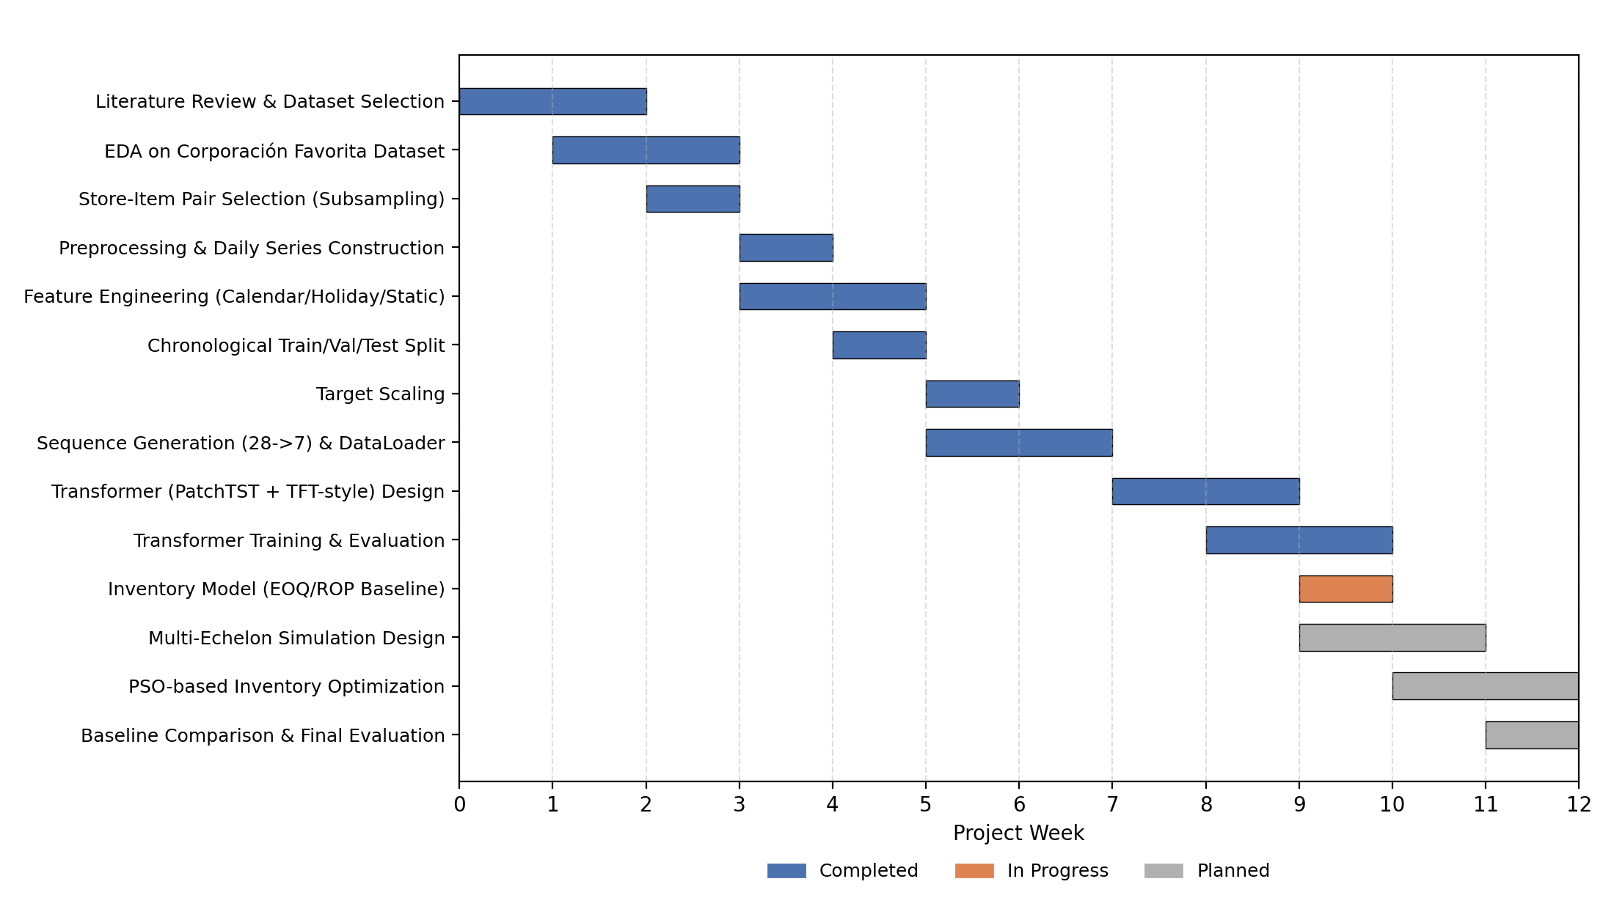
Fig.1
Project Plan Gantt Chart. This timeline illustrates the 12-week development schedule, highlighting the sequential progression of completed data engineering and forecasting tasks, alongside the in-progress and planned phases for inventory optimization and final evaluation.
The project is organized across a 12-week development period, with activities progressing from research and data preparation toward forecasting and inventory optimization. The initial stages covered the literature review, dataset analysis, exploratory data analysis, store-item selection, preprocessing, feature engineering, chronological splitting, scaling, and sequence generation. These stages established the data pipeline required for the forecasting experiments.
The following phase focused on developing and comparing the two forecasting models using the prepared time-series data. The current stage involves developing the inventory model and baseline, while the three-echelon supply chain simulation and optimization stage remain planned work. The final phase will evaluate the complete framework and compare the resulting inventory decisions with the defined baseline. The Gantt chart records these activities as Completed, In Progress, or Planned, providing a clear schedule for monitoring the project's progress and remaining work.

3. TECHNICAL SPECIFICATION
3.1 Requirements
The successful execution of this project relies on the meticulous design and implementation of a robust, data-driven architecture. Building a hybrid system that seamlessly transitions raw retail transactions into predictive insights, and ultimately into prescriptive supply chain policies, is a highly complex systems engineering task. Unlike standalone machine learning applications, this integrated framework requires bridging the mathematical unpredictability of stochastic consumer demand with the strict combinatorial logic required for inventory control. Consequently, the system requirements act as a critical blueprint, ensuring that the theoretical models can be translated into a manageable, reproducible computational pipeline.
To govern this complexity, the system's foundational requirements must establish strict operational boundaries across three distinct project phases: the initial data engineering phase, the predictive modelling phase, and the prescriptive optimization phase. Because the chosen dataset contains millions of raw transactional records fraught with noise and intermittency, the system must precisely dictate how data is filtered, scaled, and sequenced. Furthermore, establishing clear requirements ensures that the competing deep learning architectures are trained and evaluated on an absolutely level playing field, preventing methodological discrepancies from corrupting the comparative analysis.
To organize these comprehensive needs, the technical specifications are categorized into two distinct areas. First, the functional requirements will define the specific computational processes, algorithmic integrations, and step-by-step executions the system must actively perform to process the data and generate replenishment policies. Second, the non-functional requirements will dictate the qualitative constraints of the framework. These non-functional parameters are vital for ensuring that the entire pipeline maintains absolute data integrity, maximizes available computational efficiency, and guarantees academic reproducibility throughout the forecasting and optimization lifecycle.

3.1.1 Functional
The functional requirements define the specific operational capabilities the proposed framework must execute to fulfil the project objectives. To ensure a verifiable and systematic workflow, the system shall satisfy the following requirements across its primary operational stages:
Data Engineering and Processing
- The system shall ingest raw historical retail transaction data and execute automated cleaning protocols to resolve missing, negative, or invalid records.
- The system shall construct continuous, daily time-series sequences for a selected subset of retail items, strictly preventing temporal gaps.
- The system shall programmatically generate and append multivariate features, including cyclical calendar variables, localized holiday flags, promotional indicators, and static product metadata.
Predictive Modelling and Evaluation
- The system shall partition the processed data into strict chronological training, validation, and testing sets to prevent future data leakage.
- The system shall construct sliding input windows comprising exactly 28 days of historical context mapped to a 7-day predictive horizon.
- The system shall facilitate the isolated training of two competing deep learning architectures using identical data inputs and evaluation conditions.
- The system shall automatically calculate and export comparative performance metrics, including absolute and percentage error variations, for both models.
- The system shall exclusively utilize validation-set performance to select and retain the optimal model checkpoint, safeguarding the integrity of the final test-set evaluation.
Prescriptive Optimization and Simulation
- The system shall programmatically ingest the short-term demand predictions generated by the optimal forecasting model.
- The system shall instantiate a simulated, three-tier distribution network representing a supplier, a regional warehouse, and a local storefront.
- The system shall execute a nature-inspired search algorithm to identify optimal inventory policy parameters, dynamically balancing holding costs against stockout risks within the simulated network constraints.
- The system shall output a quantitative comparative analysis contrasting the algorithmically optimized replenishment decisions against standard heuristic baselines.

3.1.2 Non-Functional
The non-functional requirements define the quality attributes and performance constraints the proposed framework must strictly uphold while executing its predictive and prescriptive tasks. These requirements ensure that the system remains architecturally sound, reliable, and practically viable throughout the project lifecycle.
- Accuracy and Reliability: The predictive components must generate highly stable outputs under consistent configurations. Algorithm performance must be rigorously quantifiable using standardized evaluation metrics, ensuring that variations in output are exclusively the result of architectural differences rather than systemic instability.
- Data Integrity and Temporal Consistency: The pipeline must enforce strict chronological continuity. All preprocessing logic, feature engineering, and data scaling mechanisms must be uniformly applied across training, validation, testing, and optimization stages. The system architecture must structurally guarantee the prevention of future data leakage into historical training windows.
- Computational Scalability: Given the massive volume of the original transactional dataset, the system must optimize hardware resource utilization. The architecture must employ efficient memory management techniques, such as lazy data loading or memory-mapped datasets, ensuring that large-scale sequence generation and model training can execute successfully without exceeding available local memory constraints.
- Reproducibility: The framework must guarantee exact experimental replication. All algorithmic hyperparameters, data splitting indices, scaling weights, and environment seeds must be systematically documented and structurally retained, allowing independent verification of both the predictive evaluations and the simulated optimization results.
- Modularity and Adaptability: The codebase must maintain strict architectural separation of concerns. Data engineering, predictive modeling, and prescriptive optimization must operate as independent modules. This decoupled design ensures that individual components can be modified, tuned, or upgraded without requiring a systemic overhaul of the entire analytical pipeline.

3.2 Feasibility Study
The feasibility study provides a comprehensive evaluation of whether the proposed analytical framework can be successfully developed, integrated, and validated within strict operational and resource constraints. It critically assesses the viability of constructing the end-to-end predictive and prescriptive pipeline, explicitly accounting for the computational demands of advanced neural architectures, the structural limitations of the selected historical dataset, and the specific boundaries of the local development environment.
The foundational viability of this research is already established, as the core predictive modelling pipeline has been successfully engineered and validated. By strategically subsampling the massive raw dataset into a representative, computationally manageable subset, the project overcomes primary data processing bottlenecks. Furthermore, the downstream prescriptive stage is deemed practically feasible through the implementation of mathematically controlled heuristic boundaries, allowing the rigorous simulation of upstream distribution nodes where empirical records are currently unavailable.
To ensure a thorough validation, this assessment is categorized into three distinct domains. First, Technical Feasibility evaluates the adequacy of existing hardware, software frameworks, and algorithmic methodologies required to execute the pipeline. Second, Economic Feasibility determines whether the project objectives can be fully realized using accessible resources without necessitating prohibitive financial investments in enterprise infrastructure. Finally, Social Feasibility examines the practical relevance of the framework to modern retail operations, evaluating its potential to reliably support human decision-making while addressing inherent concerns regarding algorithmic transparency and reliance on automated planning.
Collectively, these evaluations confirm that the proposed hybrid architecture is a realistic, achievable endeavour within the allocated project timeframe.

3.2.1 Technical Feasibility
This project is technically viable as the requisite data, software stack, and modelling frameworks are fully accessible. The current technical environment supports the project's end-to-end scope through the following capabilities:
- Software Infrastructure: The core predictive pipeline is already established utilizing robust Python-based libraries, including PyTorch, Pandas, and Scikit-learn, which provide all necessary functions for advanced data processing and deep learning.
- Data Management: To handle the immense scale of the original retail dataset, the architecture successfully isolates a representative subset of 400 store-item pairs. The system further employs memory-mapped sequence files and lazy data loading, effectively minimizing RAM consumption during continuous model training.
- Hardware Constraints: The primary local limitation is a 2 GB VRAM GPU ceiling. This constraint has proven completely manageable through optimized batch sizing and highly efficient data handling protocols.
- System Integration: While empirical upstream inventory records are absent, this challenge is resolved by engineering a simulated three-tier distribution network. Because the forecasting models generate structured outputs, the subsequent nature-inspired optimization algorithms can seamlessly ingest these predictions to calculate robust replenishment policies.

3.2.2 Economic Feasibility
The project is highly economically feasible, as it relies entirely on open-source technologies, public data, and existing hardware. The financial viability of the framework is supported by the following cost-avoidance strategies:
- Software Licensing: The development environment exclusively utilizes an open-source stack. By relying on free technologies for data engineering and deep learning, the project completely eliminates the need for expensive commercial software licenses.
- Data Acquisition: The historical retail dataset utilized for predictive modelling is publicly accessible. This removes the prohibitive costs normally associated with purchasing proprietary, high-volume transactional data from commercial vendors.
- Infrastructure Costs: While neural network training is computationally demanding, the architecture mitigates the need for costly hardware upgrades. By isolating a representative data subset and utilizing efficient memory management techniques, the pipeline operates successfully on existing local hardware without requiring paid cloud computing resources.
- Operational Independence: The prescriptive optimization stage relies on algorithmic simulation rather than live integration with commercial supply chain management platforms. By modelling upstream distribution nodes mathematically, the project avoids the substantial financial investment required to access proprietary logistics networks.

3.2.3 Social Feasibility
The proposed framework is highly socially feasible, as it addresses critical operational inefficiencies while strictly adhering to ethical data practices. The societal and practical viability of the system is supported by the following factors:
- Operational Value: By improving demand estimation and replenishment planning, the framework helps reduce physical resource waste and minimizes avoidable stock shortages. This contributes to more resilient local supply chains and more consistent consumer product availability.
- Human Oversight: The architecture is designed as a decision support tool rather than an autonomous replacement for human judgment. The predictive forecasts and optimized policy recommendations provide quantitative guidance, allowing managers to apply vital contextual business knowledge that historical data alone cannot capture.
- Algorithmic Transparency: The project emphasizes analytical reliability by evaluating competing algorithms using strictly defined, standardized error metrics. Furthermore, explicitly documenting the heuristic assumptions used in the simulated distribution network ensures users fully understand the operational boundaries and limitations of the system.
- Data Privacy: The research exclusively utilizes anonymized, transactional retail data rather than personally identifiable information. Consequently, the framework avoids consumer privacy violations and introduces zero ethical risk regarding the mishandling of sensitive personal data.
Overall, the framework demonstrates significant practical value while maintaining strong ethical safeguards and human accountability.

3.3 System Specification
The system specification defines the precise hardware and software environment utilized to engineer, train, and validate the proposed analytical framework. Because processing high-volume retail time-series data and training deep neural networks are computationally intensive tasks, these specifications reflect the exact local development environment required to execute the pipeline successfully. This includes the processing power, memory capacity, and hardware acceleration necessary to generate predictive sequences and execute the subsequent prescriptive simulations.
To support this complex workflow, the system relies on a strictly modular, Python-centric software architecture. Data engineering, sequence generation, predictive evaluation, and combinatorial optimization are handled by distinct, independent modules. By relying exclusively on widely supported open-source libraries, the architecture guarantees compatibility, maximizes performance, and eliminates prohibitive commercial licensing dependencies. The following subsections detail the exact physical computing resources and software platforms required to replicate and operate the project.

3.3.1 Hardware Specification
The hardware requirements are dictated by the massive volume of the historical dataset and the intense computational demands of advanced neural architectures. The project utilizes a hybrid hardware approach, balancing local development capabilities with cloud-based acceleration:
- Local Computing Environment: The primary development environment operates on a Windows-based machine. This local architecture provides sufficient processing capability for data preprocessing, exploratory analysis, feature engineering, sequence generation, and algorithmic development.
- Graphics Processing Unit (GPU): Local hardware acceleration is provided by an NVIDIA GeForce MX330 GPU. Because deep learning requires high-dimensional tensor computations, GPU acceleration is critical for reducing training time. However, the strict 2 GB VRAM limit necessitates rigorous memory management, requiring carefully optimized batch sizes to prevent memory failures during complex predictive experiments.
- System Memory and Storage: The raw transactional dataset comprises several gigabytes, and the resulting multivariate sequence matrices require substantial disk space. To manage this without overwhelming local system RAM, the architecture relies on high-speed storage and memory-mapped data access, preventing the need to load the entire dataset into active memory simultaneously.
- Cloud Infrastructure: For highly demanding computational tasks that exceed local VRAM constraints, the project leverages cloud-based GPU instances, specifically Google Colab. This provides on-demand access to high-capacity GPUs, serving as a vital computational bridge for executing prolonged model training iterations.

3.3.2 Software Specification
The project relies on a modular, entirely open-source software stack. Python serves as the foundational programming language across all stages of the pipeline, supporting independent modules for data processing, predictive evaluation, and combinatorial optimization. The specific software environment comprises the following layers:
- Core Development Environment: Development and execution are facilitated through Jupyter Notebooks and Visual Studio Code. These integrated development environments support local scripting, rapid algorithmic testing, and seamless transitions to cloud-based execution platforms.
- Data Engineering and Visualization: The heavy numerical processing, time-series construction, and feature engineering are managed by Pandas and NumPy. NumPy is specifically utilized for memory-mapped array storage to facilitate lazy data loading. Scikit-learn is employed for critical preprocessing tasks, including target scaling and transformation. Matplotlib supports necessary graphical visualizations during the exploratory data analysis phase.
- Predictive Modelling Frameworks: All deep learning architectures are implemented natively in PyTorch. This framework provides the necessary tensor operations, automated gradient calculations, and CUDA-based GPU acceleration required to train complex neural networks efficiently.
- Hyperparameter and Policy Optimization: To ensure algorithmic rigor, Optuna is integrated into the pipeline to execute systematic, validation-driven hyperparameter tuning. For the prescriptive stage, the system utilizes a custom Python implementation of Particle Swarm Optimization to dynamically search for optimal inventory replenishment policies under defined network constraints.
By utilizing these specific, widely supported libraries, the framework ensures high modularity, allowing individual components to be developed, tested, and upgraded independently.

4. DESIGN APPROACH AND DETAILS

4.1 System Architecture
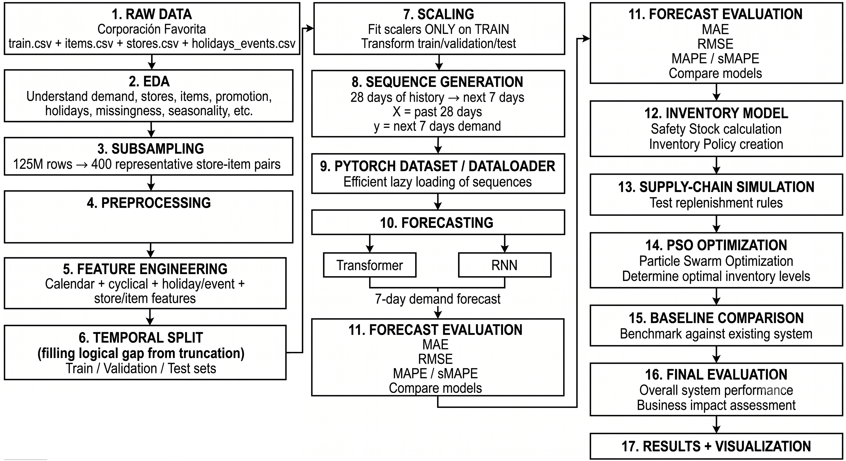
Fig.2
End-to-End System Architecture. This 17-step flowchart illustrates the complete progression of the framework, systematically transforming raw retail data into optimized inventory policies through sequential stages of data engineering, predictive forecasting, and prescriptive simulation.

The proposed system architecture is a highly structured pipeline that transitions raw retail data into optimized business decisions. As illustrated in Figure 2, the architecture flows through three primary operational phases encompassing 17 distinct steps.
The first phase establishes the data foundation. The system ingests multiple raw data files, including transaction records, item metadata, and holiday calendars (Step 1). Following an extensive exploratory data analysis to understand seasonality and missingness (Step 2), the architecture subsamples the massive 125-million-row dataset down to a computationally manageable 400 representative store-item pairs (Step 3). The pipeline then applies strict preprocessing (Step 4) and feature engineering, generating cyclical, calendar, and localized holiday variables (Step 5). To prevent future data leakage, a strict temporal split divides the data into training, validation, and testing sets (Step 6). Crucially, target scalers are fitted exclusively on the training set before transforming the remaining splits (Step 7).
The second phase drives the predictive engine. The scaled data is transformed into sliding sequences, mapping 28 days of historical input to a 7-day predictive horizon (Step 8). To maximize memory efficiency, these sequences are handled by a customized data loader utilizing lazy loading techniques (Step 9). The prepared sequences are then fed into parallel deep learning architectures (Step 10). The resulting 7-day demand forecasts are rigorously evaluated and compared using standard error metrics, including R², MAE, RMSE, and sMAPE, to identify the optimal predictive model (Step 11).
The final phase executes the prescriptive optimization. The selected forecasts feed directly into an inventory model to calculate required safety stock and establish preliminary inventory policies (Step 12). Because empirical upstream data is unavailable, these rules are tested within a simulated distribution network (Step 13). A nature-inspired search algorithm is then applied to systematically determine the optimal inventory levels under the simulated constraints (Step 14). Finally, these optimized decisions are benchmarked against existing heuristic baselines (Step 15), culminating in a comprehensive evaluation of overall system performance, business impact assessment (Step 16), and final data visualizations (Step 17).

4.2 Design
The core design philosophy of the proposed framework centers on modularity and the strict separation of concerns. The system is engineered to seamlessly bridge predictive demand analytics with prescriptive inventory optimization. To achieve this, the architecture is divided into distinct, interconnected modules, ensuring that data engineering, comparative forecasting, network simulation, and policy optimization remain logically isolated. This decoupled approach allows each component to be evaluated and modified independently without disrupting the overall pipeline. The following subsections detail the specific logical execution of this design, illustrating the internal data progression and external user interactions required to generate optimal replenishment decisions.
4.2.1 Data Flow Diagram
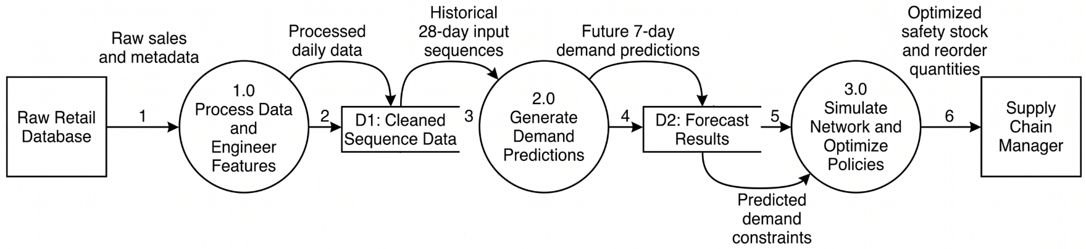
Fig. 3
Data Flow Diagram. This diagram maps the continuous movement of information through the system, detailing how raw database records are systematically processed into stored forecasts and ultimately converted into actionable policies for the supply chain manager.
This Level 1 Data Flow Diagram illustrates the systematic movement of information through the proposed architecture, mapping the exact pathways between external entities, active computational processes, and internal data stores.
The data pipeline initiates at the external source, the Raw Retail Database, which supplies unrefined transactional sales and item metadata (Data Flow 1). This information enters Process 1.0, where the system executes data cleaning, target scaling, and feature engineering. The resulting standardized, daily time-series records are then deposited into the first internal repository, denoted as D1: Cleaned Sequence Data (Data Flow 2).
To initiate the predictive phase, the system extracts historical 28-day input sequences from D1 (Data Flow 3) and feeds them into Process 2.0. This computational node represents the deep learning forecasting engine. After evaluating the sequences, Process 2.0 outputs future 7-day demand predictions (Data Flow 4), which are systematically written to the second repository, D2: Forecast Results.
In the prescriptive phase, these forecast results are extracted as rigid demand constraints (Data Flow 5) and passed into Process 3.0. This final node conducts the multi-tier network simulation and executes the metaheuristic optimization search. Finally, the system outputs the resulting mathematical policies, specifically the optimized safety stock and reorder quantities (Data Flow 6), to the terminating external entity representing the Supply Chain Manager. This structured flow ensures that predictive insights are seamlessly translated into actionable operational policies.

4.2.2 Use Case Diagram
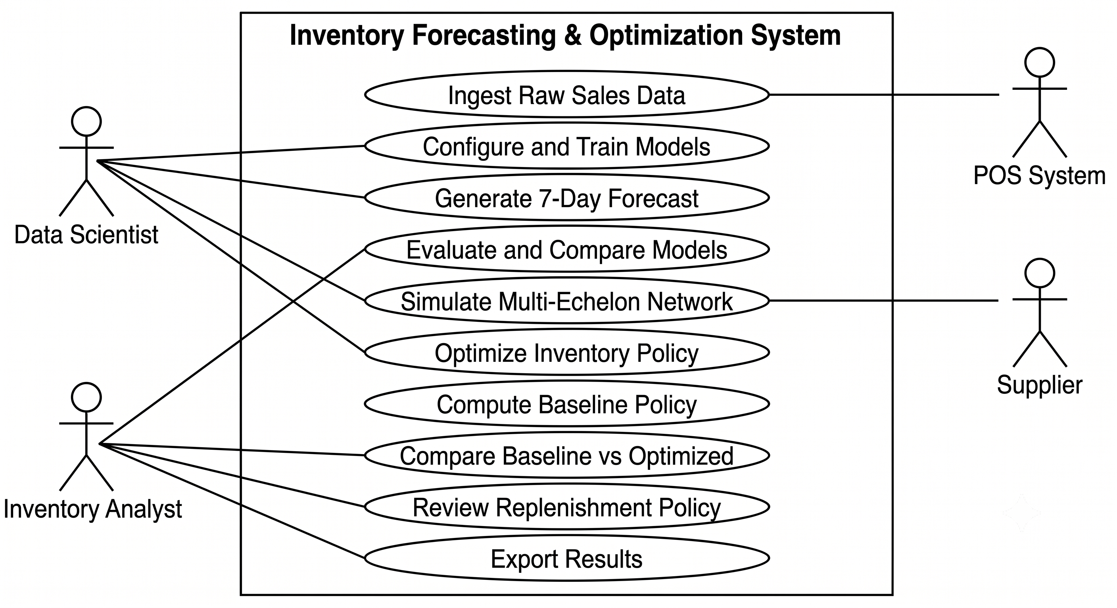
Fig. 4
Use Case Diagram. This diagram maps the functional interactions between four external actors and the ten primary use cases of the proposed inventory forecasting and optimization system.
The Use Case Diagram illustrates the functional interactions between external actors and the proposed analytical framework, identifying the specific operations each actor can trigger without describing the internal implementation logic. As shown in Figure X, the system boundary encapsulates ten distinct use cases, accessed by four external actors.
The Data Scientist serves as the primary technical operator, responsible for configuring and training the competing predictive architectures, generating the seven-day demand forecasts, initiating the multi-echelon network simulation, and executing the inventory policy optimization. The Inventory Analyst occupies the decision-making role, evaluating and comparing model performance, reviewing the generated replenishment policies, benchmarking optimized decisions against classical baselines, and exporting the final analytical results.
Two secondary actors represent external system-level interactions. The POS System functions as the automated data source, supplying raw transactional sales records that initiate the entire analytical pipeline. The Supplier operates as an external entity within the simulated distribution network, representing the upstream fulfillment node that interacts with the multi-echelon simulation stage.
The diagram clearly separates the predictive workflow from the prescriptive workflow. The Data Scientist drives the upstream forecasting stages, while the Inventory Analyst governs the downstream policy evaluation, ensuring that automated optimization outputs are always subject to informed human oversight before operational adoption.

5. REFERENCES
Journals:
[1] C. Anusha and S. Maiti, “Optimizing retail inventory and sales through advanced time series forecasting using fine tuned PrGB regressor,” IEEE Access, vol. 13, pp. 165336–165352, 2025, doi: 10.1109/ACCESS.2025.3605209.
[2] E. Spiliotis, S. Makridakis, A.-A. Semenoglou, and V. Assimakopoulos, “Comparison of statistical and machine learning methods for daily SKU demand forecasting,” J. Oper. Res. Soc., pp. 1–25, 2020, doi: 10.1007/s00107-020-06161-7.
[3] T. Demizu, Y. Fukazawa, and H. Morita, “Inventory management of new products in retailers using model-based deep reinforcement learning,” Expert Syst. Appl., vol. 237, pt. A, p. 121422, 2024, doi: 10.1016/j.eswa.2023.121422.
[4] C. Ntakolia, C. Kokkotis, P. Karlsson, and S. Moustakidis, “An explainable machine learning model for material backorder prediction in inventory management,” Sensors, vol. 21, no. 23, p. 7926, Nov. 2021, doi: 10.3390/s21237926.
[5] M. Zohdi, M. Rafiee, V. Kayvanfar, and A. Salimaraad, “Demand forecasting based machine learning algorithms on customer information: An applied approach,” Int. J. Inf. Technol., vol. 14, pp. 1937–1947, 2022, doi: 10.1007/s41870-022-00900-3.
[6] K. Douaioui, R. Oucheikh, O. Benmoussa, and C. Mabrouki, “Machine learning and deep learning models for demand forecasting in supply chain management: A critical review,” Appl. Syst. Innov., vol. 7, no. 5, p. 93, Sep. 2024, doi: 10.3390/asi7050093.
[7] M. Seyedan, F. Mafakheri, and C. Wang, “Order-up-to-level inventory optimization model using time-series demand forecasting with ensemble deep learning,” Appl. Soft Comput., vol. 146, p. 110659, 2023, doi: 10.1016/j.asoc.2023.110659.
[8] K. Gavhane, “Digital transformation in SME retail operations: An empirical study of AI-driven inventory management systems in regulated markets,” J. Small Bus. Manage., vol. 62, no. 4, pp. 1–25, 2025.
[10] A. Hossam et al., “Revolutionizing retail analytics: Advancing inventory and customer insight with AI,” IEEE Access, vol. 11, pp. 63489–63502, 2023, doi: 10.1109/ACCESS.2023.3287564.
[11] S. Singh, “Enhancing inventory planning in retail SMEs through data-driven demand forecasting,” Int. J. Innov. Invent. Soc. Sci. Humanities, vol. 3, no. 3, pp. 272–277, Mar. 2026, doi: 10.58806/ijissh.2026.v3i3n01.
[12] L. Bo et al., “Enhancing supply chain efficiency resilience using predictive analytics and computational intelligence techniques,” IEEE Access, 2024.
[13] X. Zhang et al., “Transformer-based demand forecasting and inventory optimization in multi-echelon supply chain networks,” Journal of Banking and Financial Dynamics, 2025.
[15] P. Nayak et al., “An integrated demand forecasting and inventory optimization model using EOQ/EPQ and hybrid metaheuristic algorithms under uncertainty,” International Journal of Scientific Research in Modern Science and Technology, 2026.
[16] G. H. Nayak et al., “Meta-transformer: Leveraging metaheuristic algorithms for agricultural commodity price forecasting,” Journal of Big Data, 2025.
[17] Q. Tu et al., “Demand forecasting and inventory optimization of distribution equipment: A fusion model based on genetic algorithm and machine learning,” PLOS ONE, 2025.
[19] O. Zabraoui et al., “Modular AI for supply chain resilience: Blending RL, forecasting, causal inference, and evolutionary coordination for inventory optimization,” Results in Engineering, 2026.
[20] O. Zabraoui et al., “A comparative study of multi-algorithm optimization for inventory analytics in supply chains,” Supply Chain Analytics, 2025.
[21] A. Fallahi et al., “A constrained multi-item EOQ inventory model for reusable items: Reinforcement learning-based differential evolution and particle swarm optimization,” Expert Systems with Applications, 2022.
[23] Z. Wang et al., “Research on AIGC-based supply chain inventory demand forecasting model and nonlinear optimization strategy,” Journal of Combinatorial Mathematics and Combinatorial Computing, 2025.
[24] N. Kourentzes et al., “Optimising forecasting models for inventory planning,” International Journal of Production Economics, vol. 225, p. 107597, 2020.
[25] M. R. Hasan et al., “AI-powered inventory optimization models: A strategic framework for improving stock management in US supply chains,” International Journal of Accounting and Economics Studies, 2026.
[26] J. Behera, “AI-integrated probabilistic optimization for inventory control under stochastic demand,” Journal of Mathematics and Statistics, 2026.
Conference:
[9] A. Fatima and M. A. Salam, “A data-driven predictive framework for inventory optimization using contextaugmented machine learning models,” in Proc. 2024 IEEE Int. Conf. Big Data (BigData), Washington, DC, USA, 2024, pp. 1–7.
[14] S. Wang, “Forecasting demand and controlling inventory using Transformer-based neural network optimized by whale optimization algorithm,” in Proc. 2024 Guangdong-Hong Kong-Macao Greater Bay Area Int. Conf. Digital Economy and Artificial Intelligence, 2024.
[18] N. Xue et al., “Evolving deep CNN-LSTMs for inventory time series prediction,” in Proc. 2019 IEEE Congress on Evolutionary Computation (CEC), 2019.
Not a journal/conference paper:
[22] R. Barati et al., “Gym-invmgmt: An open benchmarking framework for inventory management methods,” arXiv preprint, 2026.

